Swim Galas
How do I know when my kid is ready and what to expect on the day?
In terms of whether a swimmer is ready to compete in a ‘beginner’ meet it can be hard to tell until they do a competition! Sometimes a really natural swimmer might not like competing, sometimes a swimmer that isn’t the most natural might just love the buzz of competition. The best series galas to get an introduction to competitive swimming are the Coverdale ‘league’ galas. This is an informal ‘league’ between us, Musselburgh, Tranent and Haddington. It is specifically for development level swimmers to introduce them to competing in a super informal (but fun) environment e.g. kids can start in the water if they want rather than dive. There are 4 rounds with each club hosting one round each. The only way to be ‘disqualified’ and not be invited back is when your times become too fast! It’s also a brilliant way to get introduced to the ‘club’ element of galas. Porty has tended to have the smallest team the last couple of years – but been the loudest in cheering on their own swimmers.
Then there are other more traditional multi-club galas like the Musselburgh Fun Mee in June that are also specifically designed for young simmers with no disqualifications and kept informal.
There are a couple of ways we try to ensure any gala you are told about is appropriate for younger swimmers. The coaches will do there best to sign post when appropriate galas are coming up by talking to the kids at training. But clearly not all kids will make all training and we appreciate messages can get a little lost in interpretation from coach to swimmer to parent!
The other way is that the gala organiser will set an age limit – so if you tried to enter a young child in the East District summer event it wouldn’t let you. In addition when we send emails out about specific meets we try to ensure it only goes to the squads it is relevant for. So you wouldn’t receive the East District one as we won’t send to Dev 1 (unless you also had a swimmer in a higher squad to whom it might be relevant). Communications for galas will through a combination of Team Unify (which includes how you sign up for the gala) and What’s App (to get your attention better than email!).
The only way really to experience what a gala is like is to attend one! One thing we would ask is that if you have entered a gala please think carefully before withdrawing. If we have enough swimmers of the right age/ gender then we will enter them into a team relay. The clubs pays for this entry. But if one swimmer withdraws we have to withdraw the whole team from the relay. We won’t get the cost back but far more importantly it means the other swimmers won’t get to do a relay. This has happened on a number of occasions and is always disappointing.

How do I enter my swimmer into a gala?
When entering swim galas you will now be charged the entry fee on your credit card when the meet file is generated after the sign up deadline. Therefore, you need to know how to enter a meet and how to add a credit card. You won’t be able to enter a meet without a credit card on file. Please note there is now 2.95% per transaction plus 20p fee. Therefore, the meet entry prices have been adjusted accordingly e.g. a £5 race entry becomes £5.15; £6 race becomes £6.18; £9 race becomes £9.27; £12 race becomes £12.36 etc. Plus 20p on top of any total.
Please also note that in some cases you will not need to sign up to individual races. You may just need to declare you are attending the gala.
Adding a Credit Card
NB: after November all members should have a credit card on file for paying training fees so this will be less of an issue. In most cases you will need to pay for entering a gala but in some cases you won’t (such as Coverdale).
Team Unify Site
You can also use this online help article but much more detailed help below
https://support.gomotionapp.com/en/articles/6424463-parents-how-to-add-a-credit-card-or-ach-to-account-in-your-wallet
NB: there is a link from the Meet Entries site to enter CC details if you haven’t already. But this sometimes doesn’t work so it’s better to do it this way.
Go to My Account – Set Up Autopay
You should see this screen
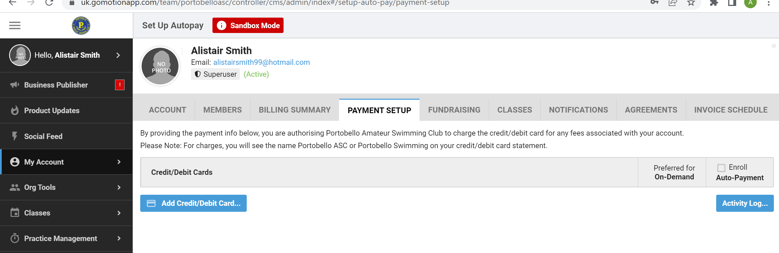
Click Add Credit/ Debit Card . . .
Complete details
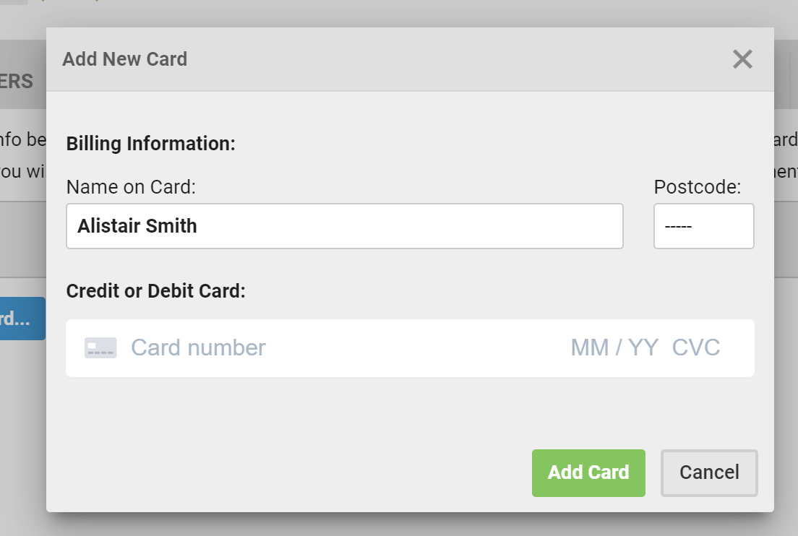
Go Motion/ On Deck App
On home screen click Add Credit/ Debit Card
Then click Add New Card
Then complete details
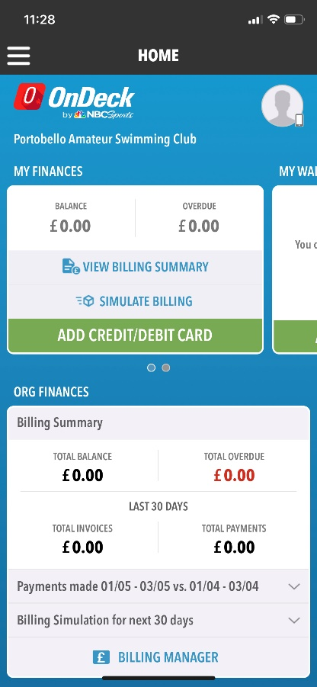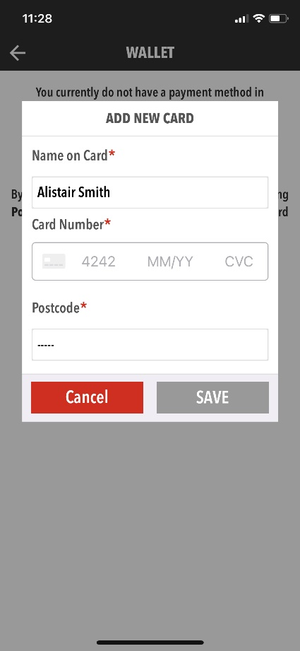

Gala Entries
Team Unify Site
Please note we will soon start using a new club email address for dealing with gala entries – portyascgalaentries@gmail.com. It is still Gail Hogarth behind the scenes doing all the hard work though.
You can also see this online help article – but much more detailed help below.
https://support.gomotionapp.com/en/articles/6650818-how-to-commit-sign-up-for-a-meet-event
Go to Events & Competitions – Team Events
Click on the event you wish to enter – you should then see this screen. This gives some basic details including the registration deadline, breif description and the gala organisers meet programme (if you look at this programme in detail then please ignore the details about paying for entries – members pay the club and the club pays the organiser i.e this information is for the club, not the member).
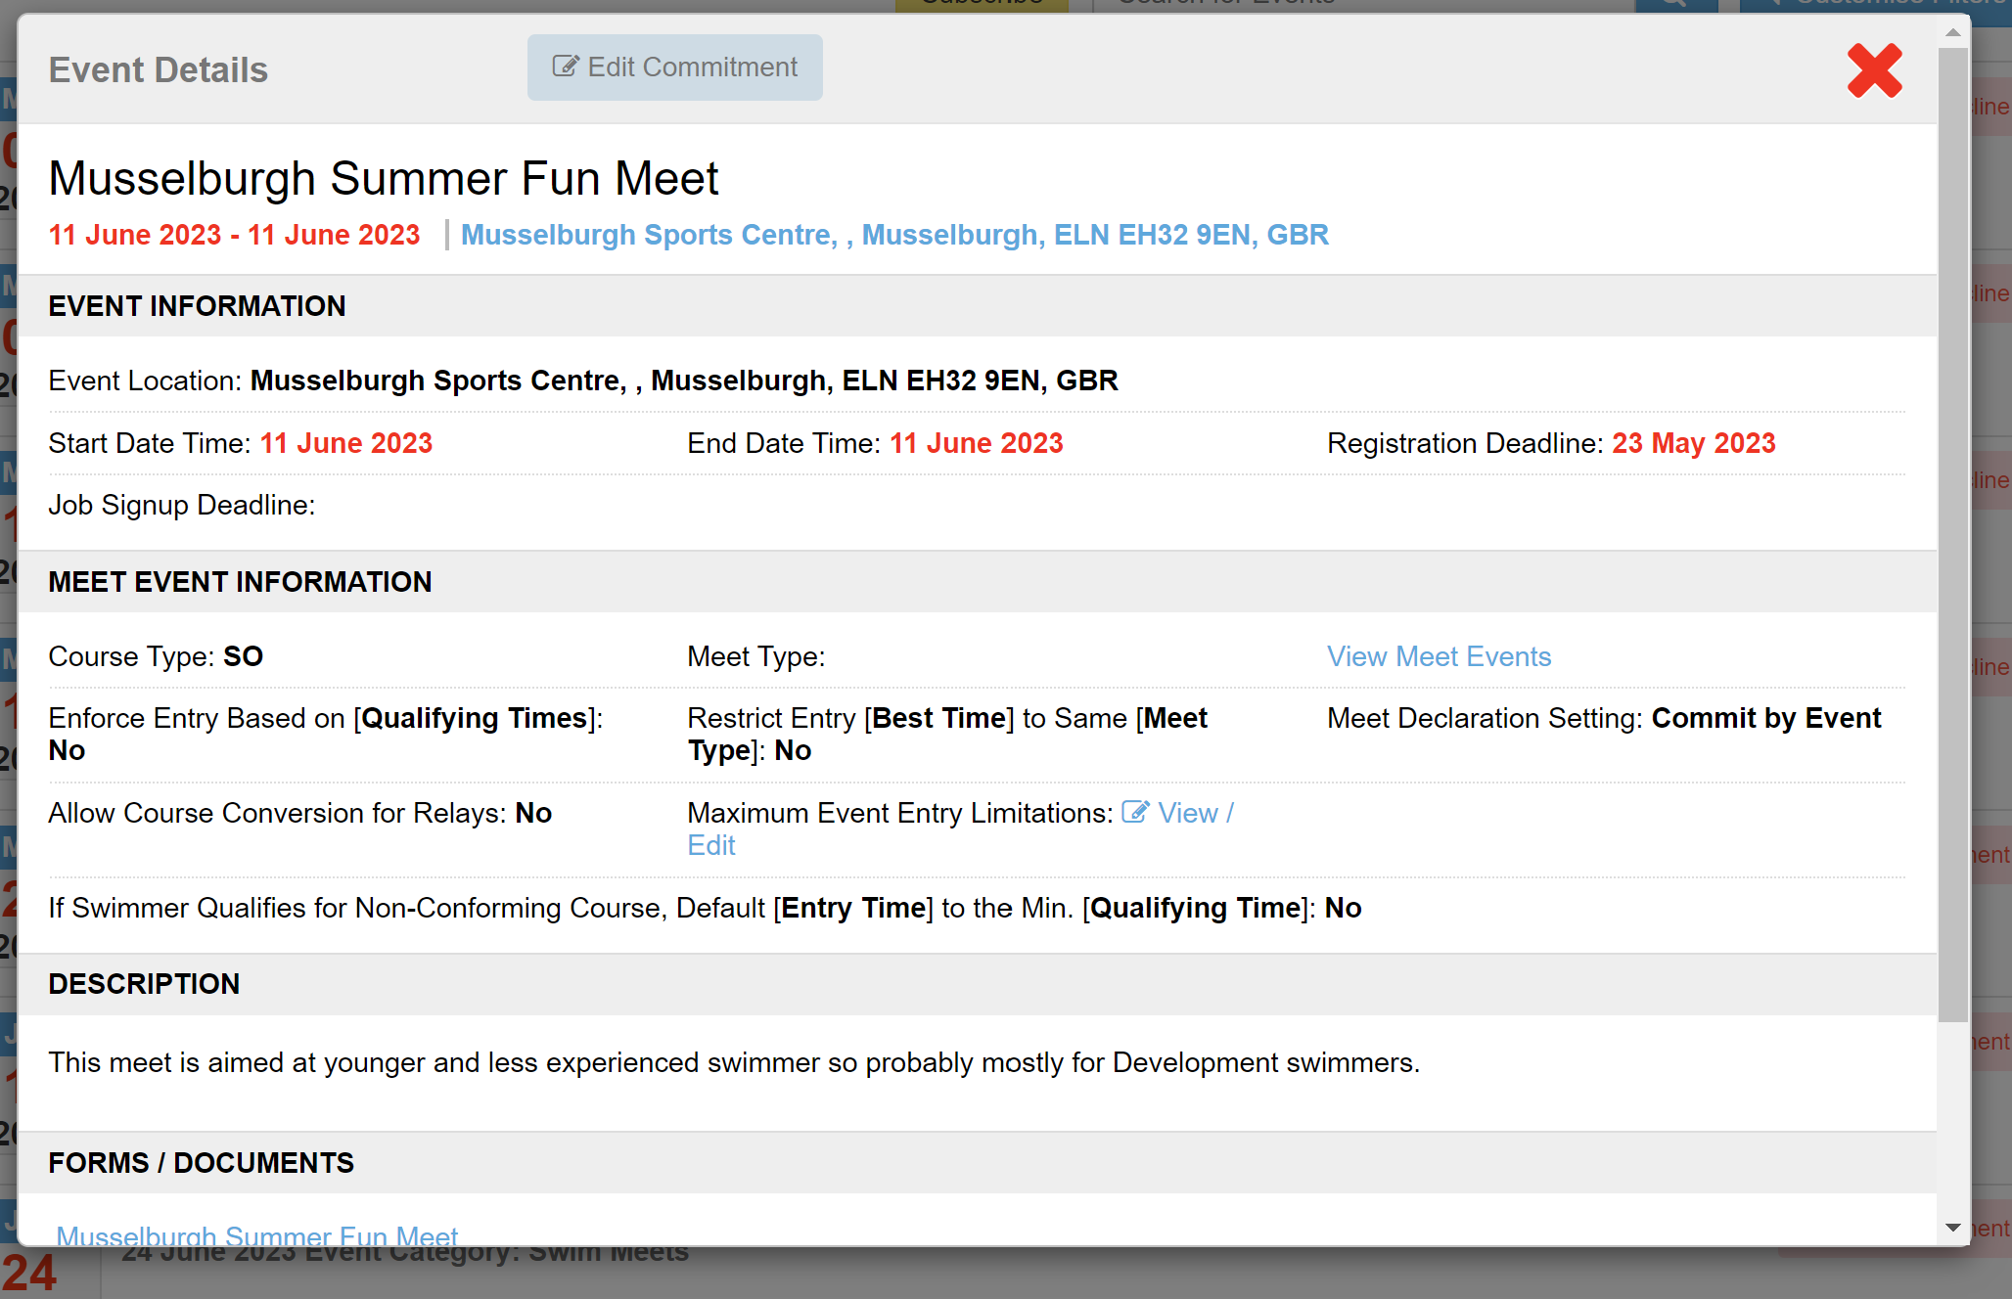
Click on Edit Commitment
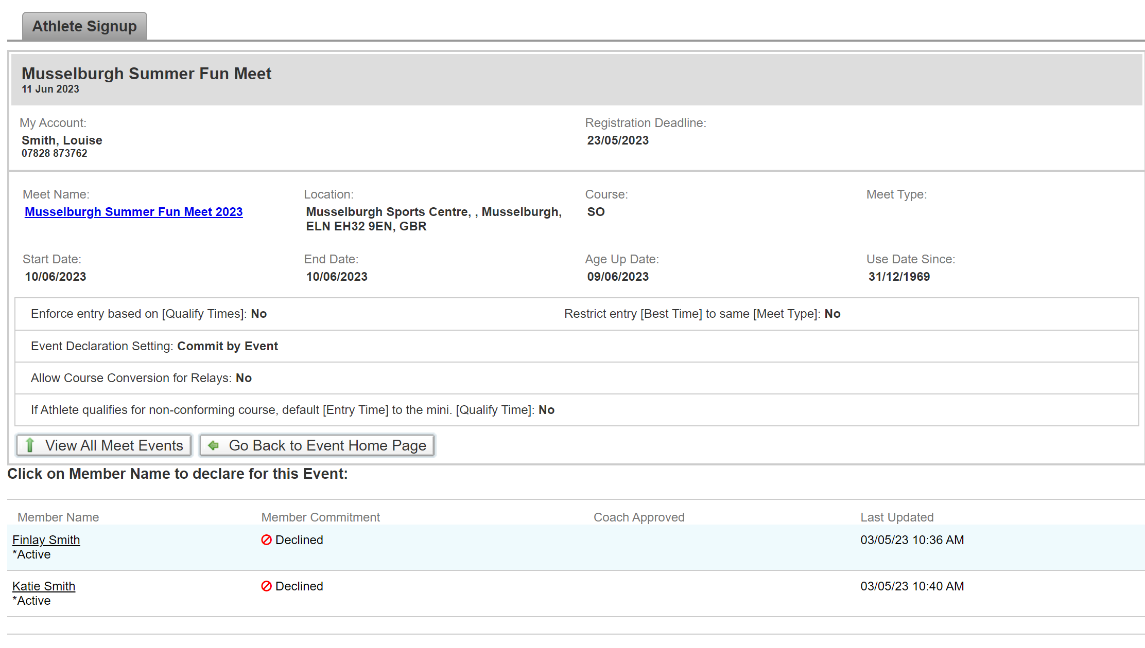
You swimmers will initially show as “Undeclared” rather than “Declined” (sorry – I had already done mine before putting this together!). Click on the swimmer you wish to enter.
There will be some more notes (events and timinings). Scroll to the bottom to Declare. This will initially show

Declare to attend or not. If you Decalare to attend then the events will drop down to tick. NB: if the gala is a ‘declare only’ then you will not need to enter individual races as per below.
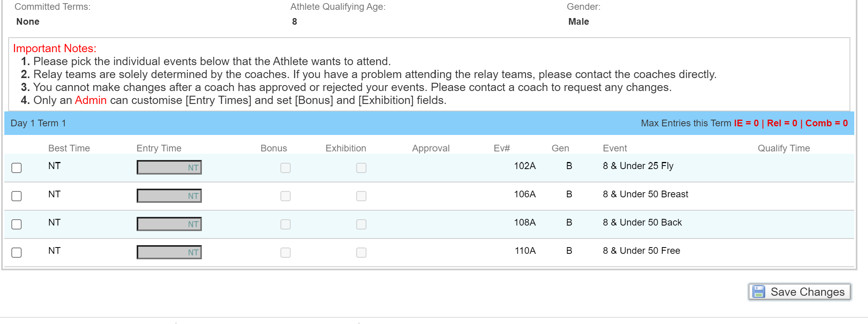
Tick the events and then Save Changes. You will then be taken back to the Athlete Sign up page and it will show your swimmer as Declared. Then repeat for any other swimmers.
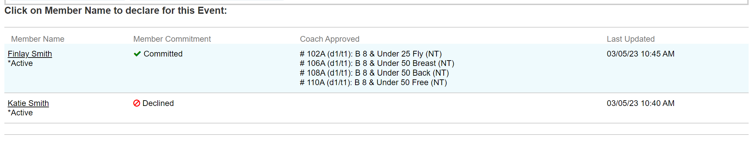
Note that if you try to Declare a swimmer that doesn’t qualify for the event (usually too young/ slow or too old/ fast) you will see the following.

Go Motion/ On Deck App
Click three line icon at top left to get drop down menu.
Go to Events & Jobs – Events and Meet Entries
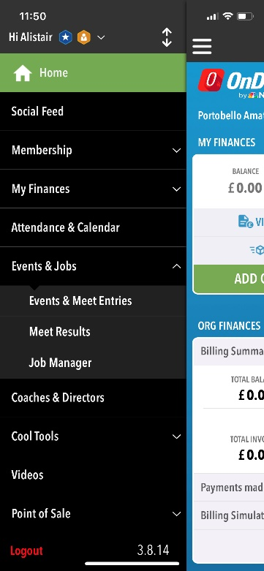
Click on the Meet you want to enter
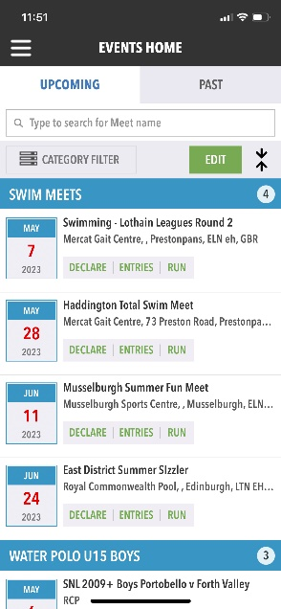

Click on the Declare button at top
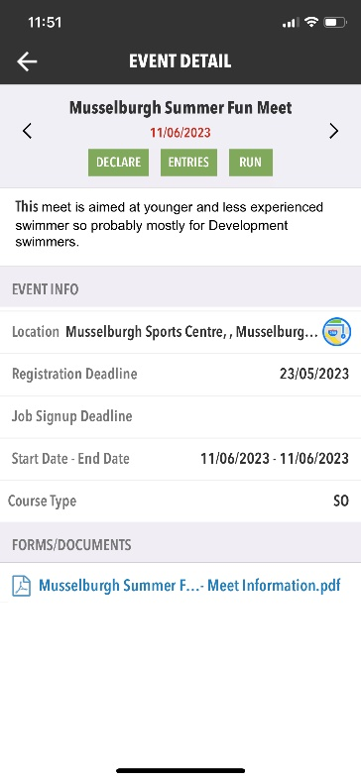
Your swimmers should show Undeclared (I’d already entered mine!). Click on the swimmer you want to enter.
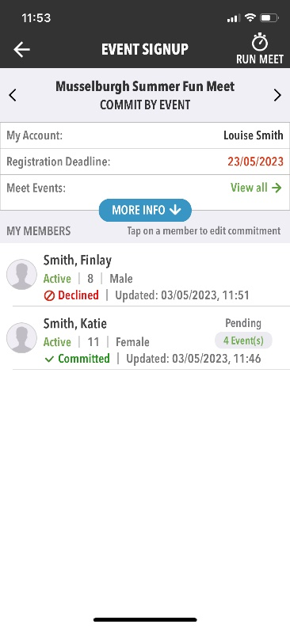

Click on Yes Please. You may need to click on the blue bar to get the individual entries to drop down. Then tick each event to enter and click Apply.
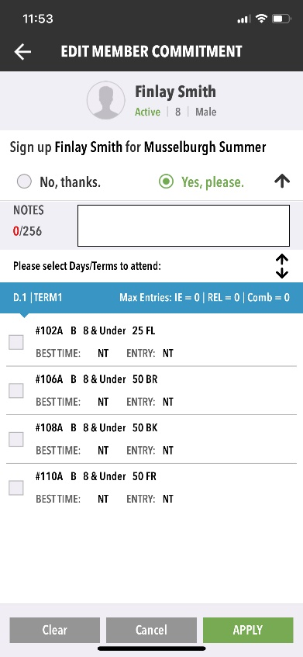
You should be taken back a stage to show your swimmer is now committed.
